Report

1. **Accessing the Website**

First import the database using data.sql

Using visual studio, click Hotl.sln to enter,then

click Views/Home/Login.cshtml

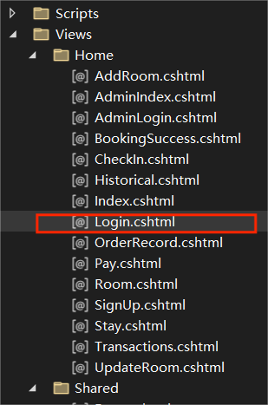

Then you go to the initial page

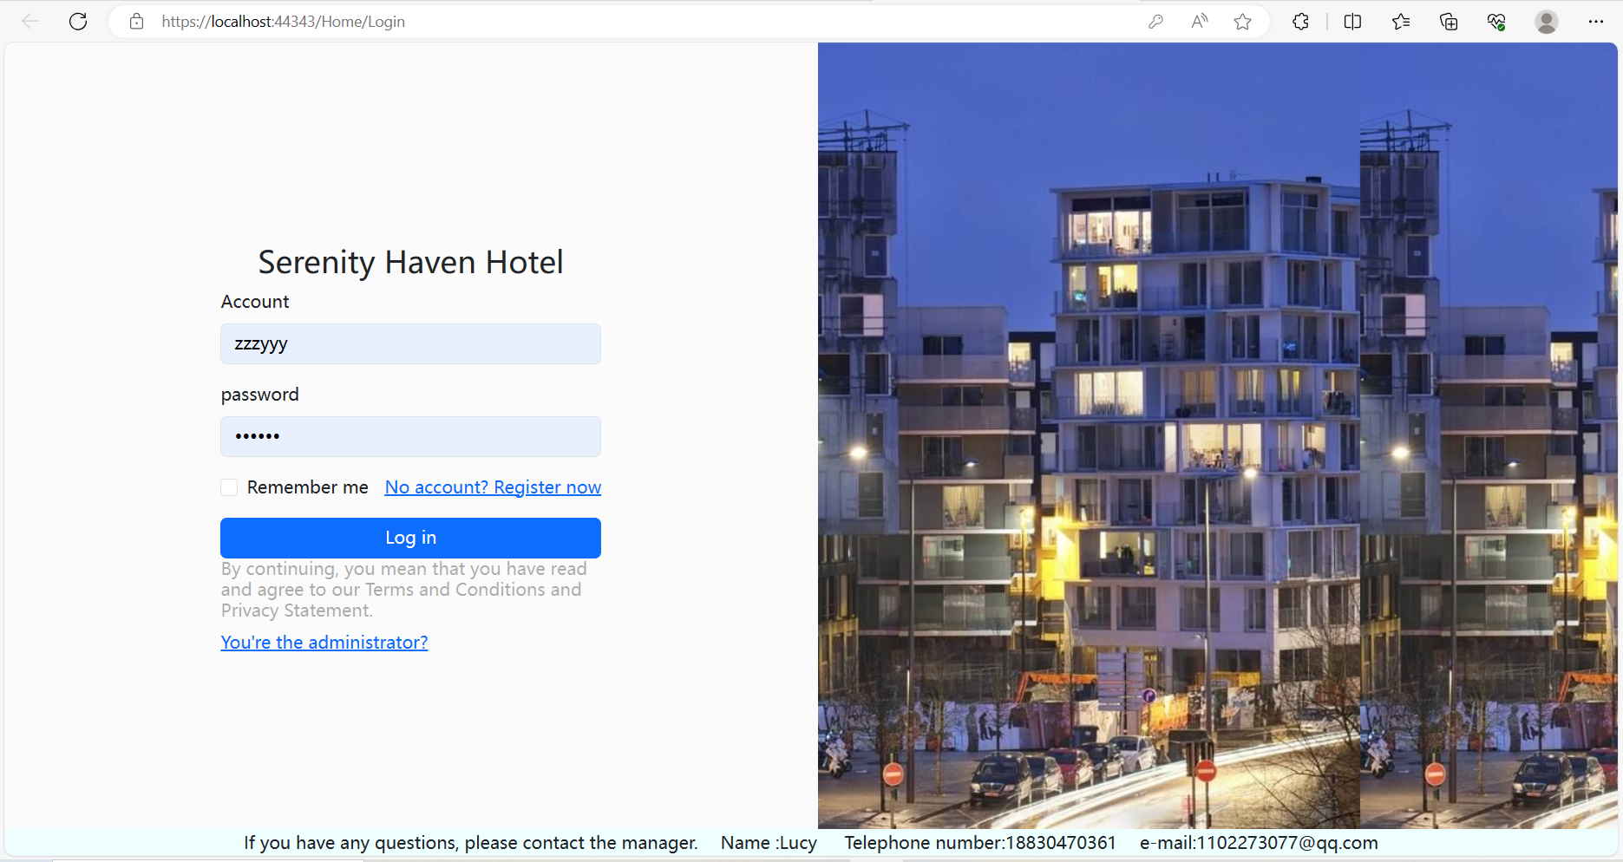

2. **Website Layout**:

At the beginning of the entry is the login interface of the hotel website, there are two login methods, one is the user login to book rooms and other functions. The second is the hotel administrator login for room query and check in and other functions.( The following picture shows the administrator login interface)

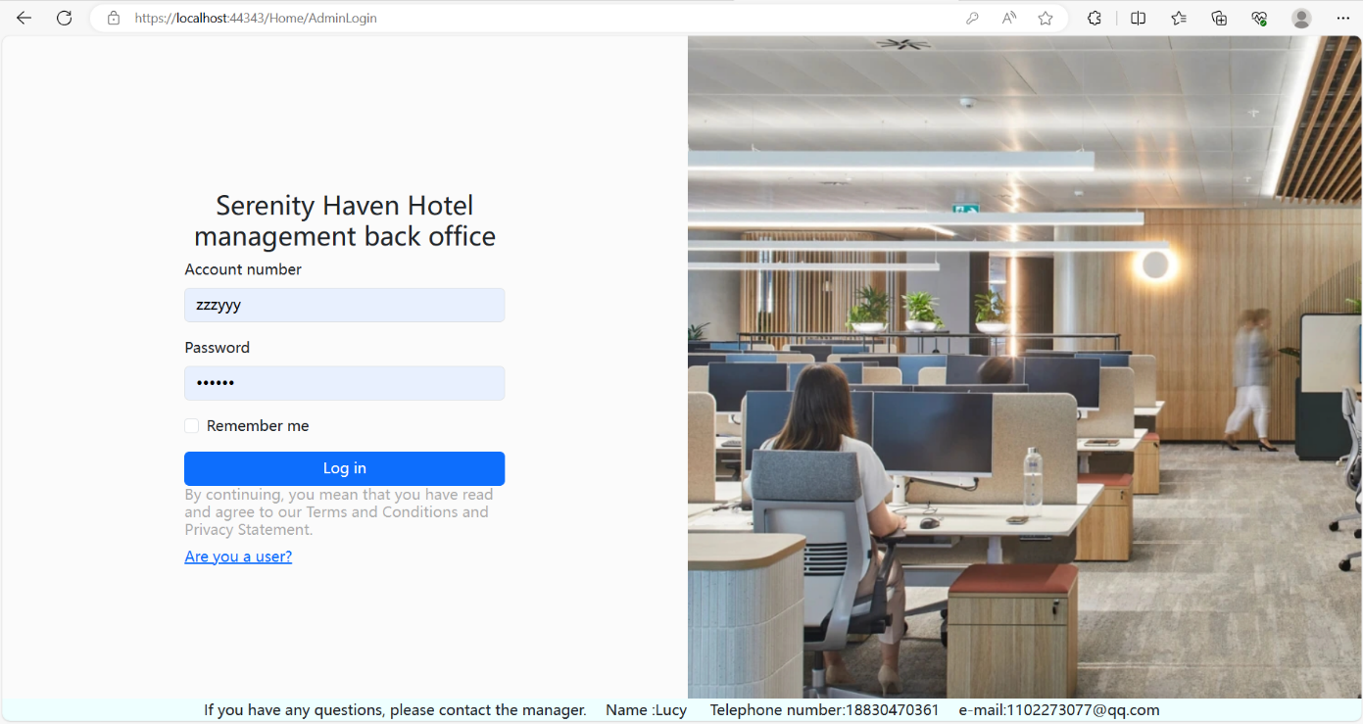

The administrator has his own account and password in the background, and if the user does not have an account, he can choose to create a new account (below is the registration user interface).

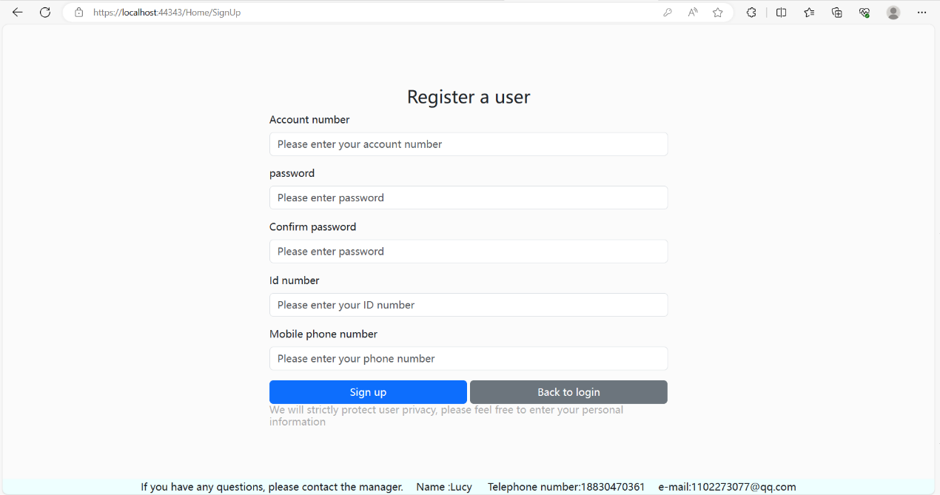

After login, there is a mobile interface of hotel photos. There is hotel information in the lower right corner.

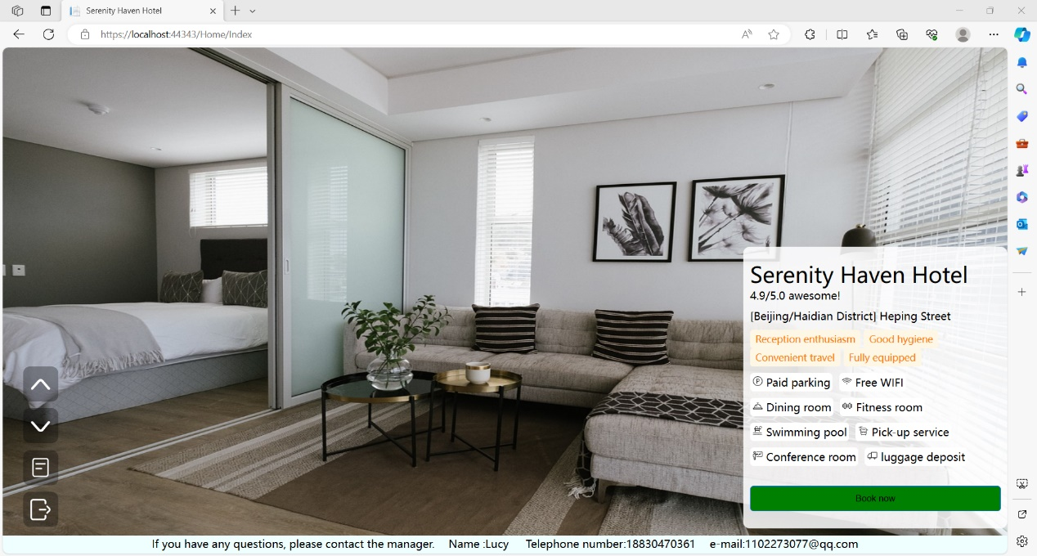

Click Book now to enter the hotel booking interface.

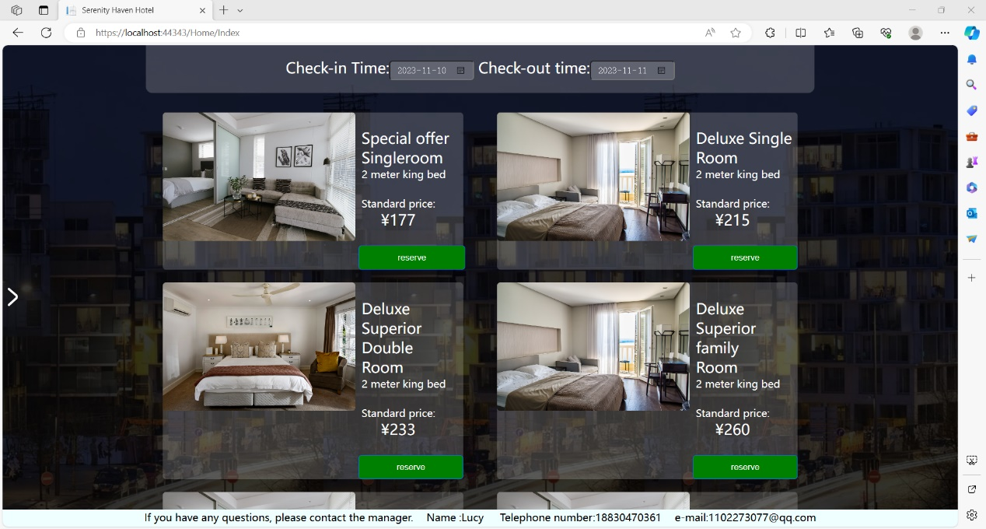

Then the following is the administrator login interface

(user name: Tom password: 123456)

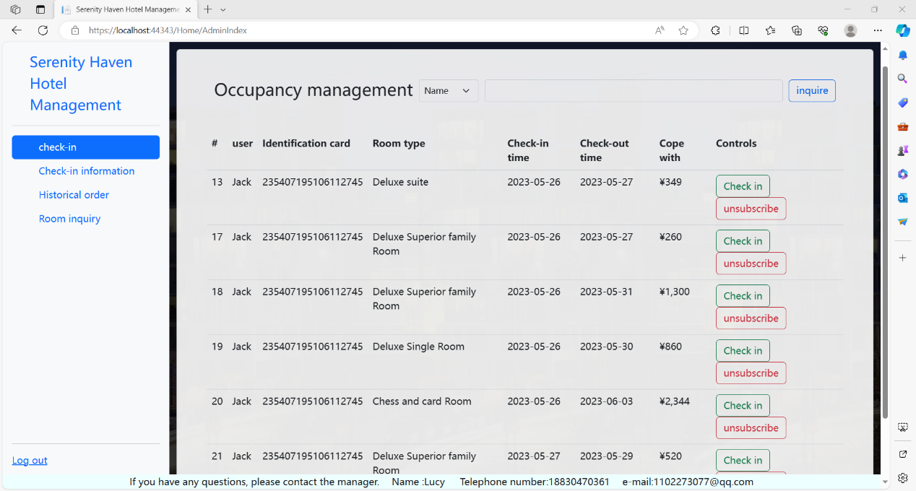

These are the general layout of the web page, the following website specific explanation.

3. **Utilizing Website Features**

First of all, go back to the login interface of the web page. If there is no user, it is necessary to register the user. The registration content includes Account number, password, Confirm password, id nuber, and Mobile phone number. If the input format does not meet the specified requirements, an input error reminder will be generated (as shown below).

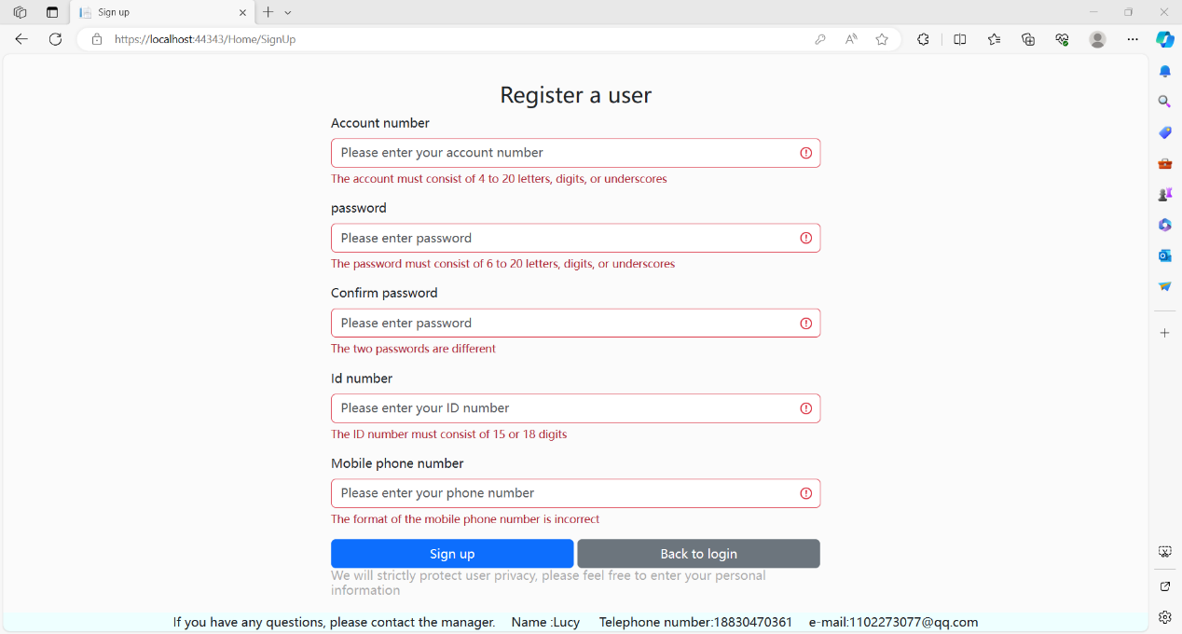

After successful registration, you will enter the initial interface of the hotel, the middle of the interface is the hotel's promotional photos, the above two buttons in the lower left corner can be switched pictures, the third button can be an order query, the fourth button is to exit the user login. In the lower right corner is the introduction of hotel information. Click on Book now to book a room.

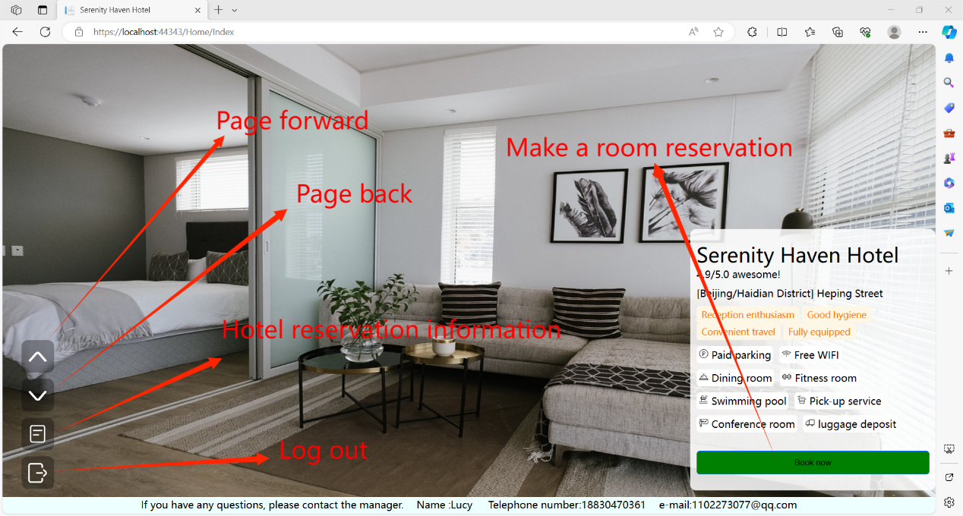

Below is the interface after clicking Book now, you can select the time on the top, and you can select the type of room on the bottom

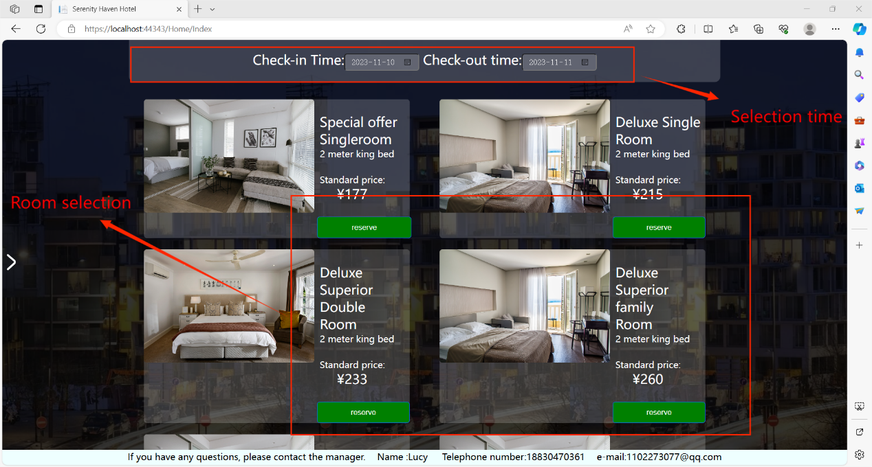

After selecting a room to book, the time can also be adjusted, and the details of the room and the person who made the reservation are displayed.

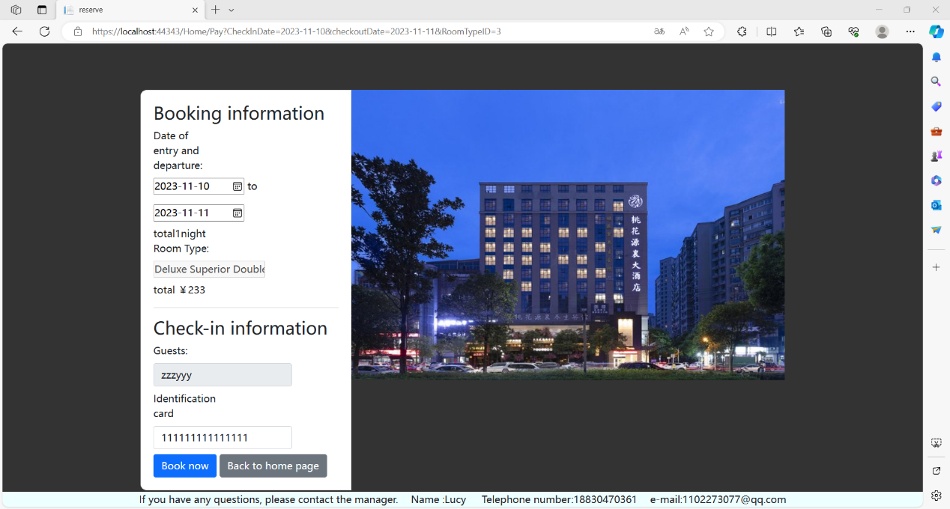

After confirming the reservation, a successful reservation screen will be displayed, along with some booking details.

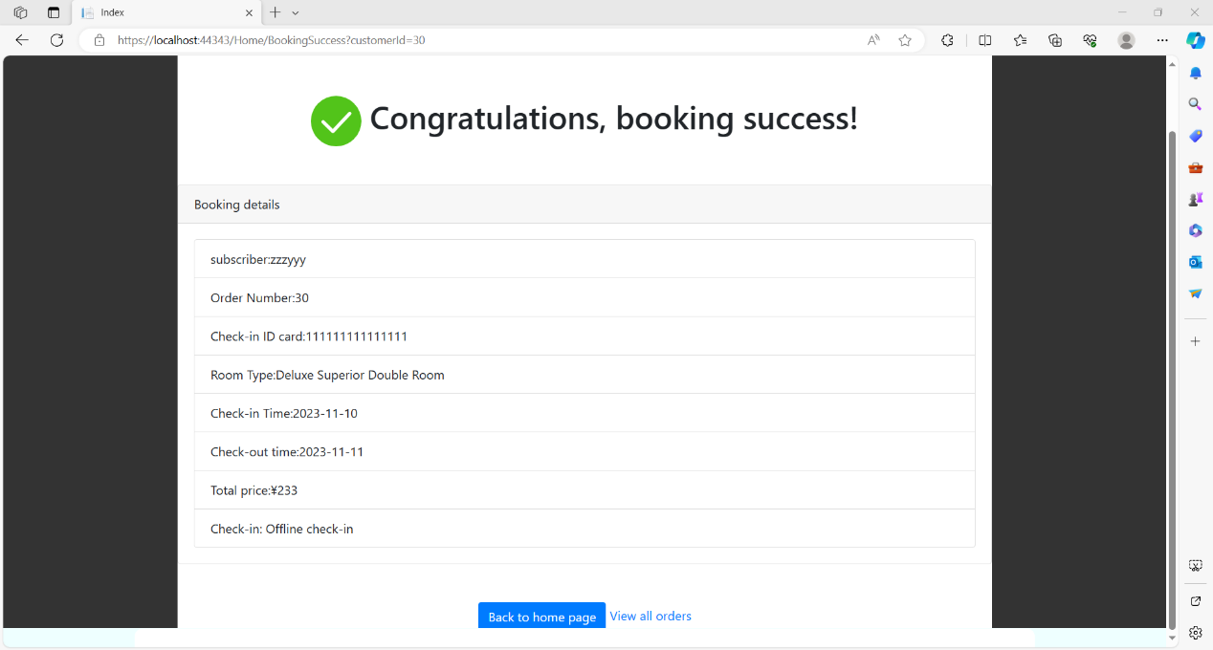

Click “view all orders” to see all the booking information.

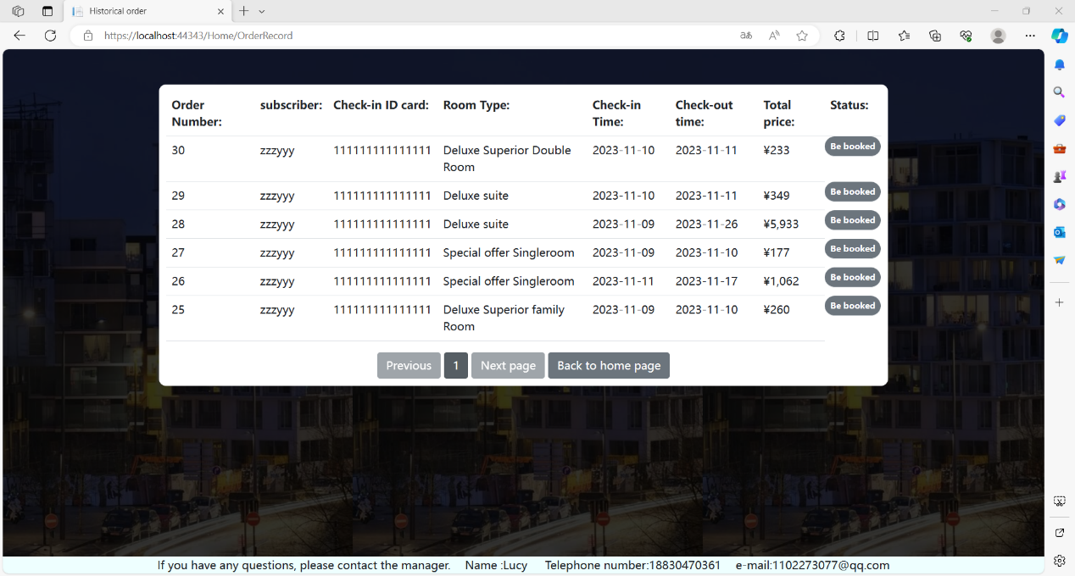

The customer reservation function is over. The following is the introduction of the hotel administrator interface. First, return to the home page and switch to the administrator login interface for login (account: Tom password: 123456).

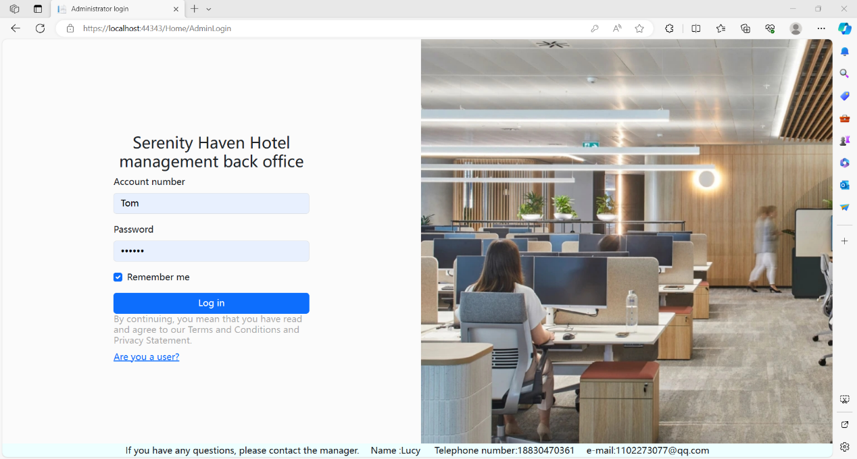

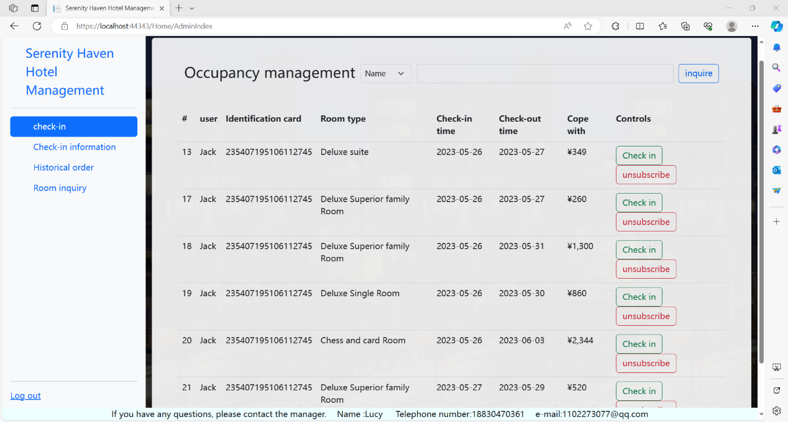

The hotel manager has four functions. They're “check in”,”Check-in information”,”Historical order”,”Room inquiry”.

in the “check in” function, you can choose to check in or unsubscribe the user's predetermined information.

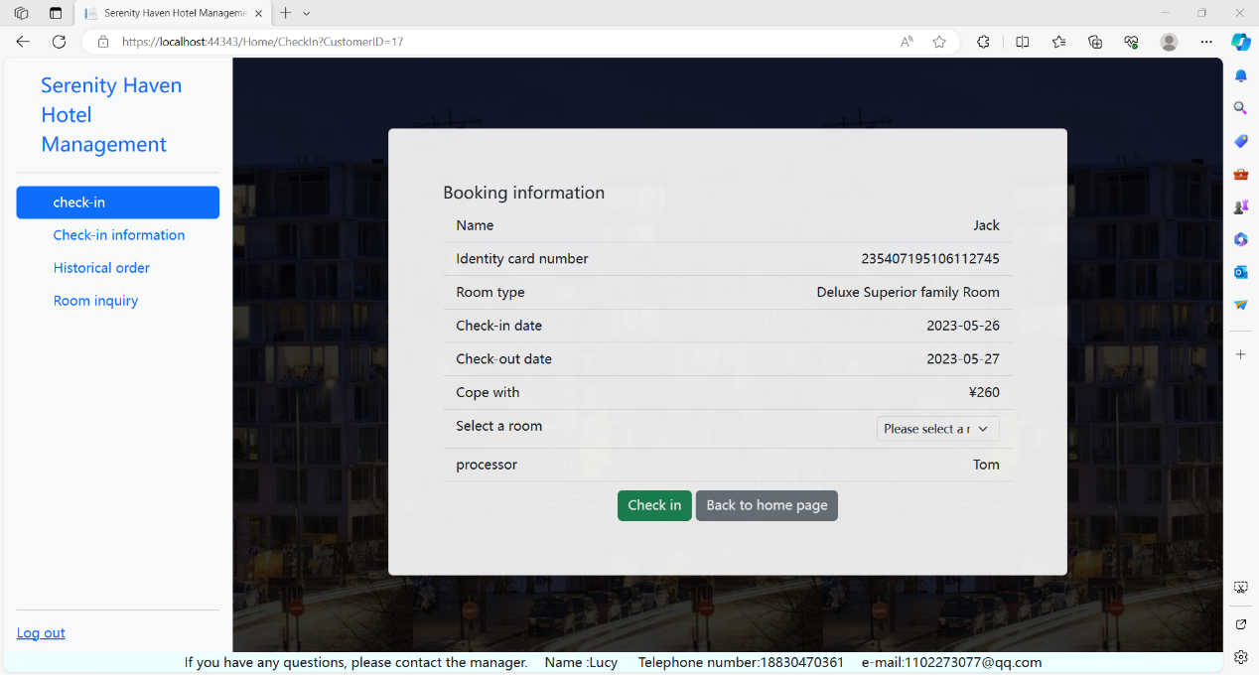

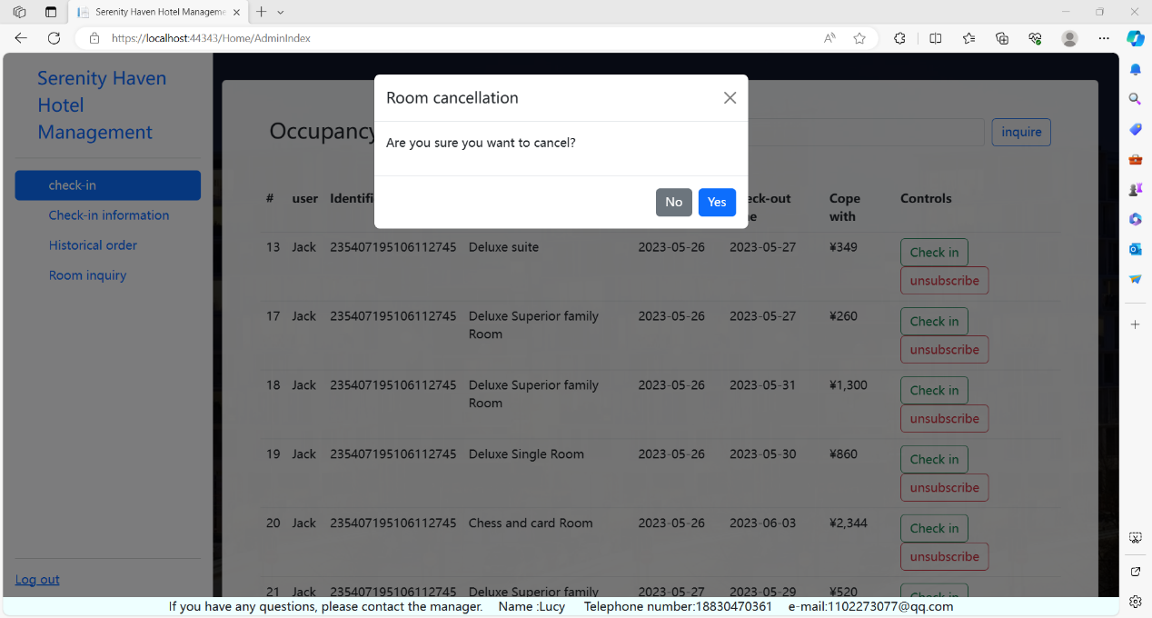

In the “Check-in information” .Customers who have already checked in can renew or check out, and can choose the date of renewal when renewing.

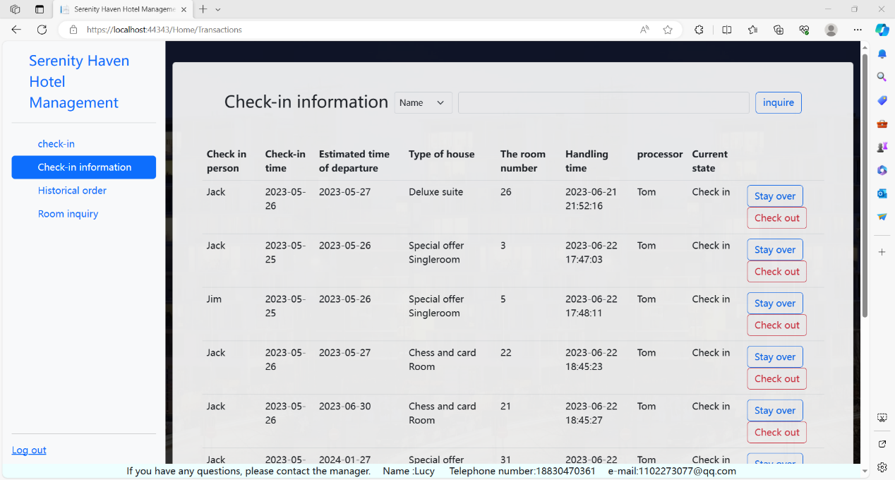

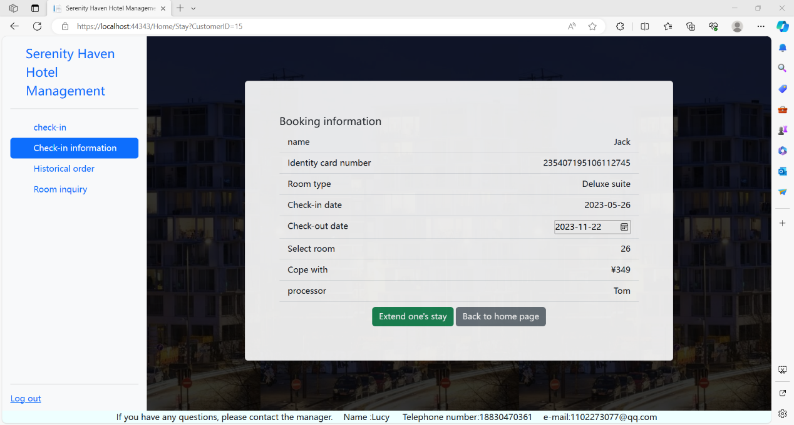

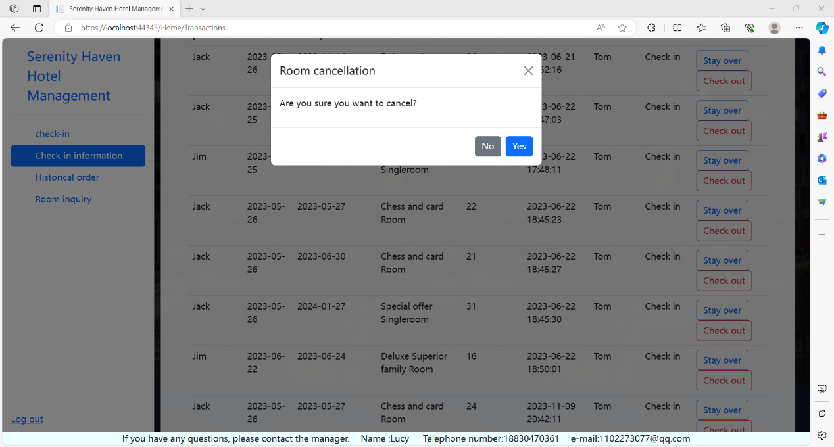

In the “Historical order” administrators can view historical orders.

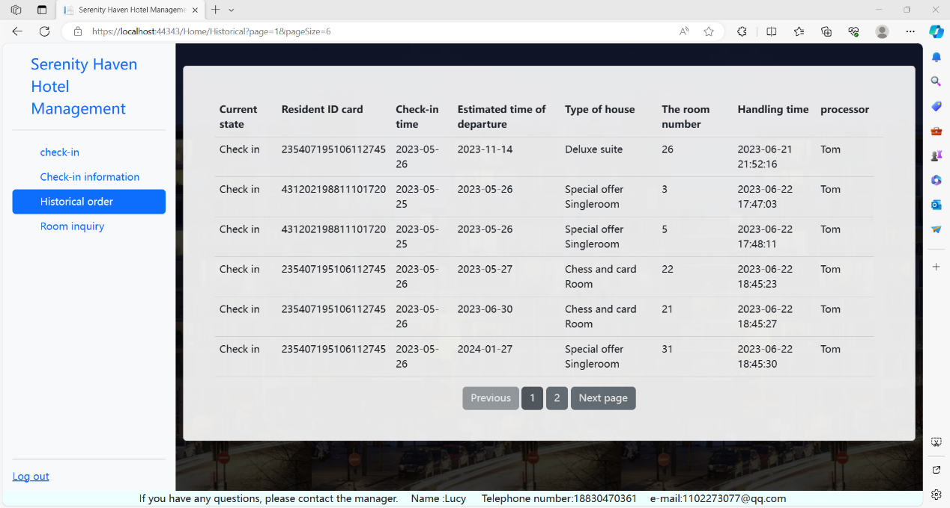

In the”Room inquiry”. Can manage hotel rooms， can change the room type, can also add rooms.

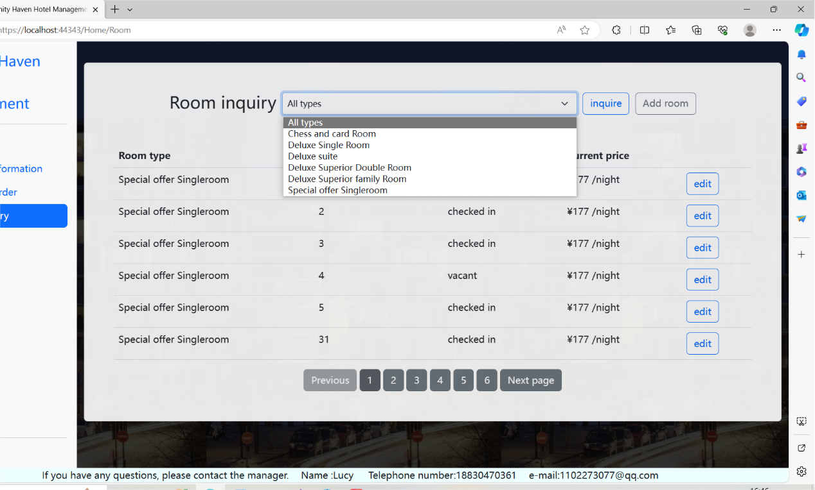

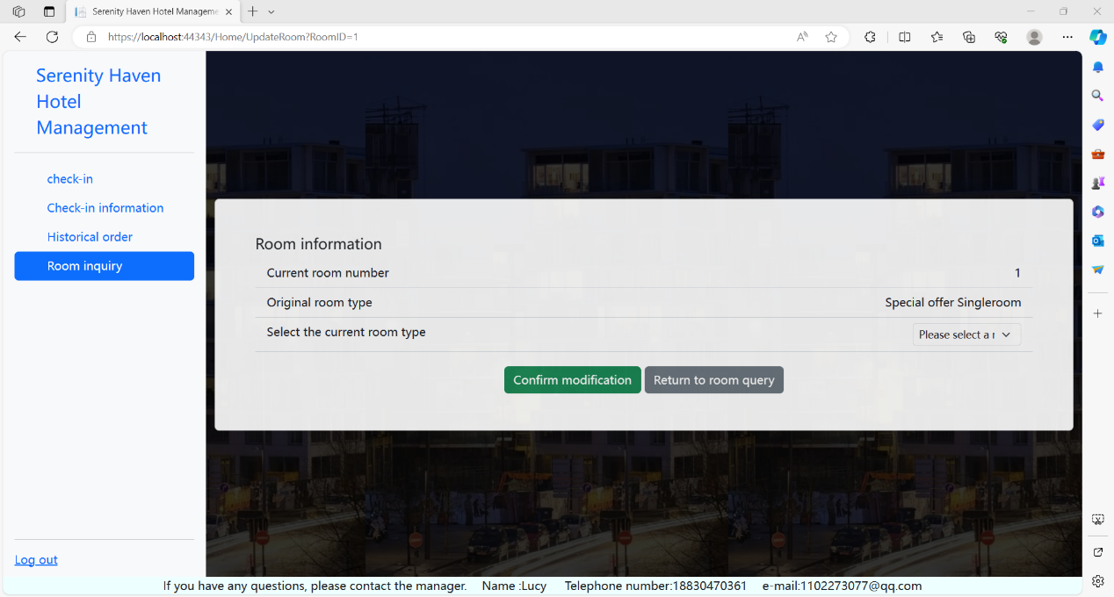

These are the main features of this website.

4. **Technical Demonstrations**

1. Models

When the user logs in to create an account, it will import all its information into the database. The user will change the status of the room in the background when selecting the free room according to the free room displayed in the background. At the same time, the administrator can change the user's housing information through operation in the background and change the status of the room at the same time.

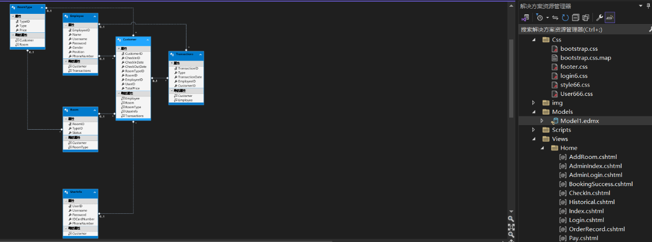

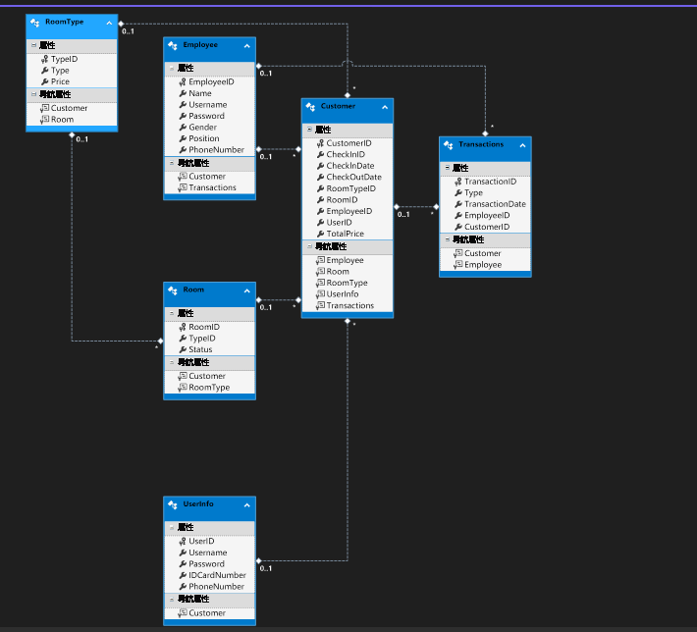

2. CSS

Below are screenshots of some css files

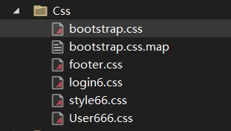

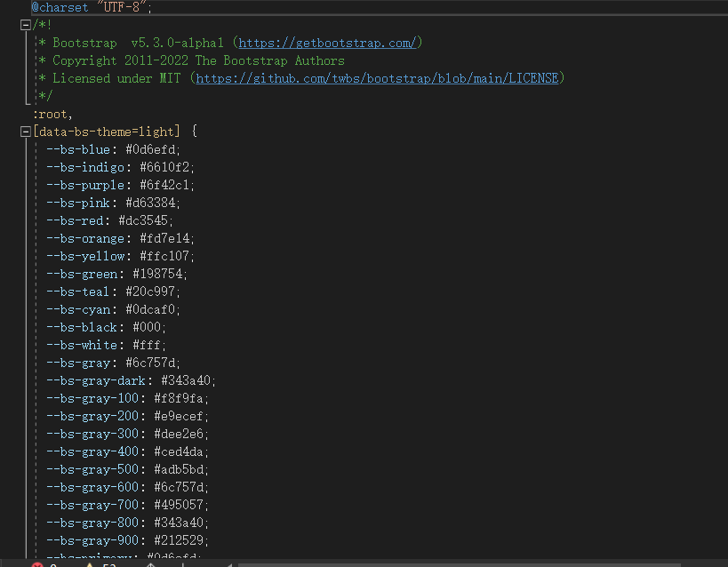

Here is the css style for the footer on each page, and here we set its common style and set it at the bottom.

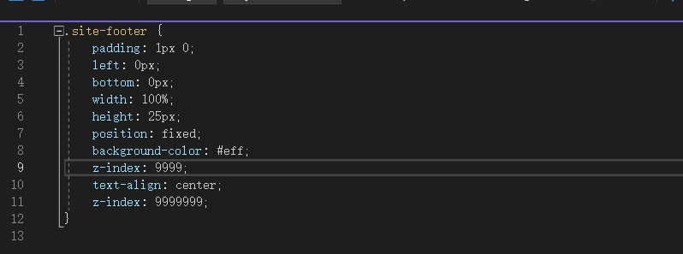

The css style of the login page is set here

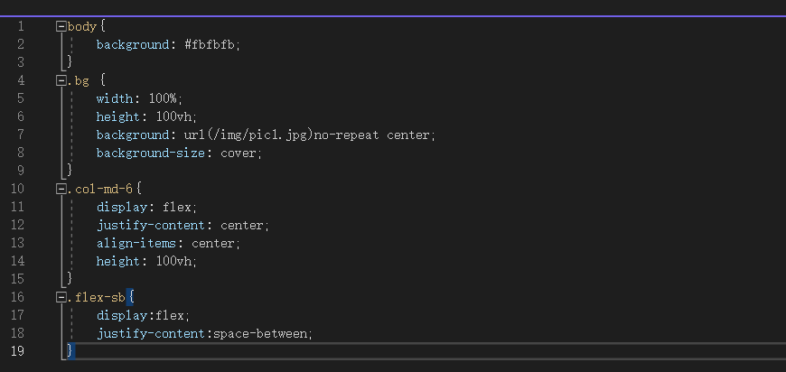

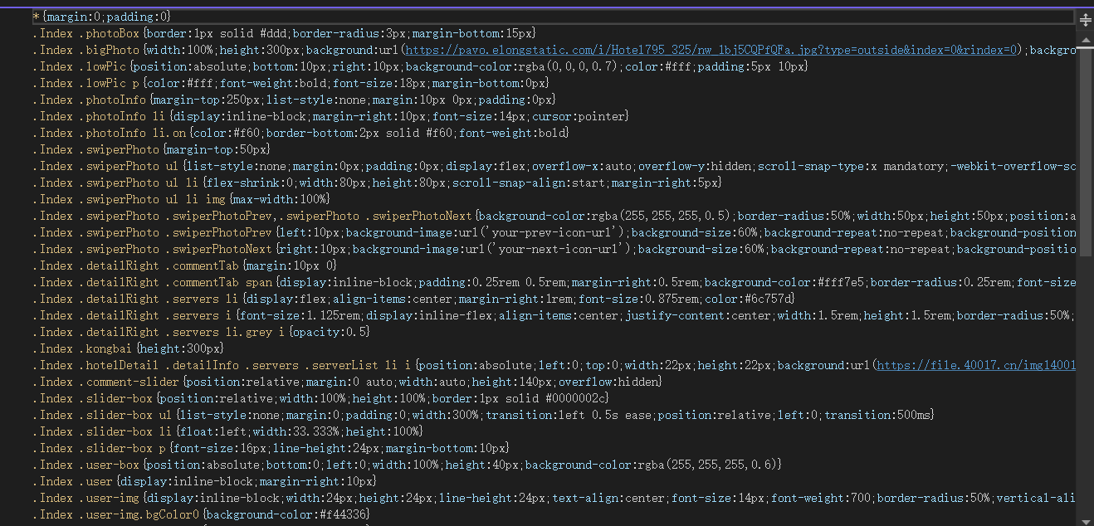

3. JavaScript

Here is the hotel page after the user landed, the hotel's publicity pictures can be rotated on the home page

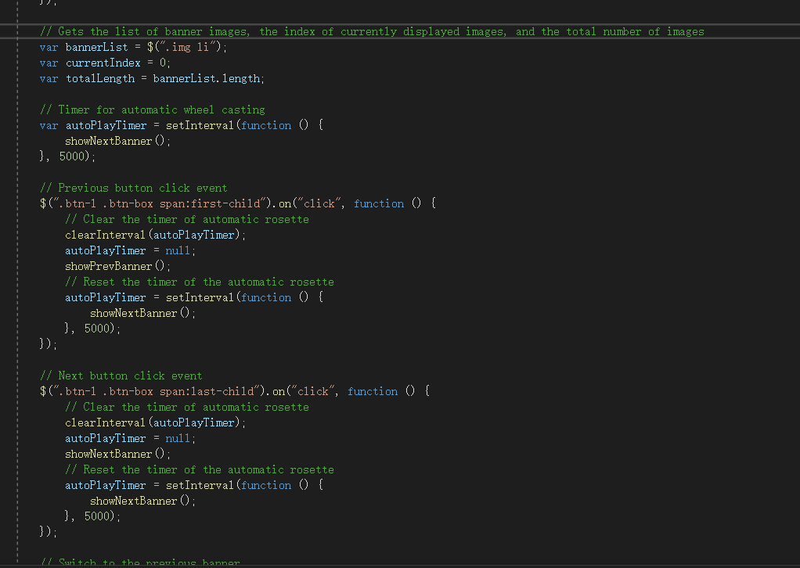

The following is the js used for booking and check-out

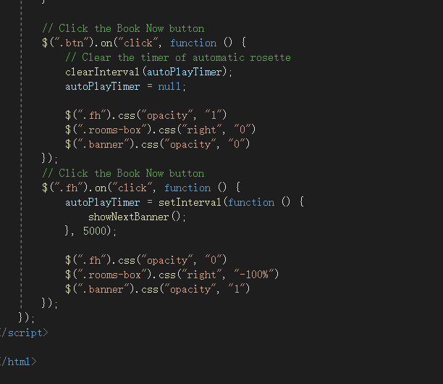

This is where you get the time of the day and initially set the reservation time and check-out time when you book a room

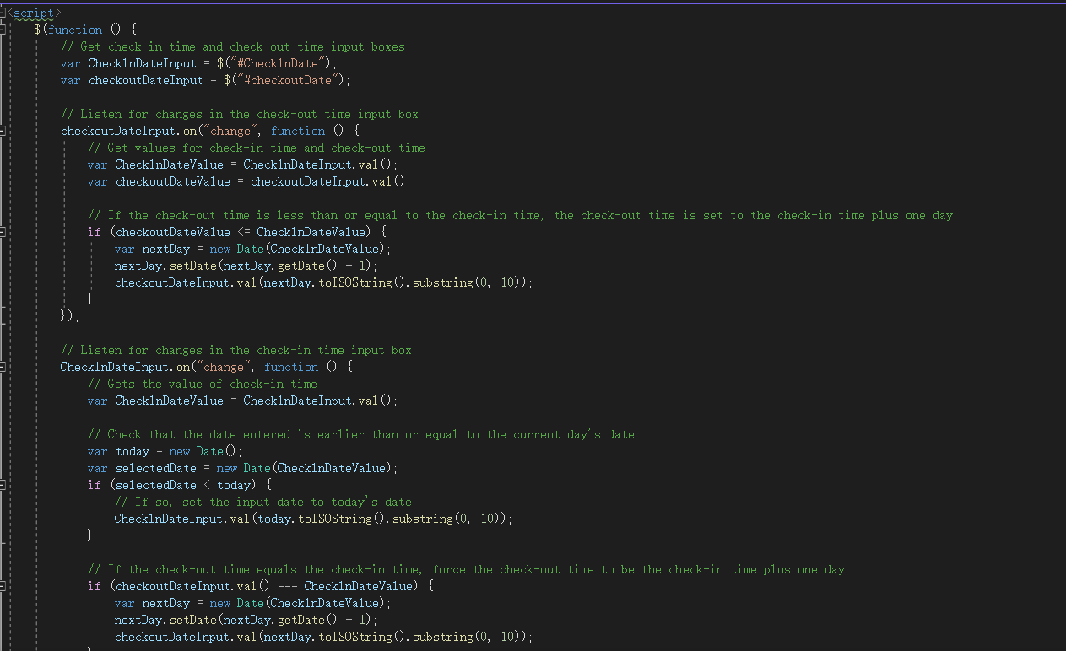

4. Feature Implementation

Searching Function

A search function is provided here to jump if the searched letter corresponds to the name and information exists in the database

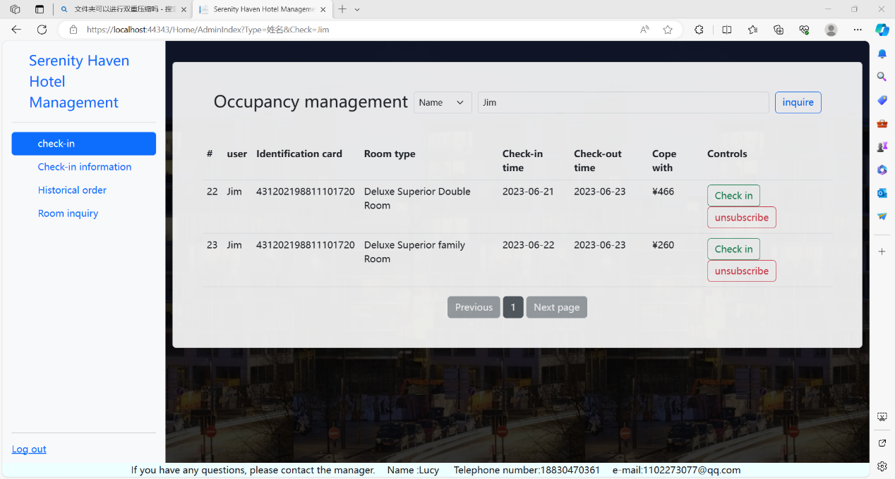

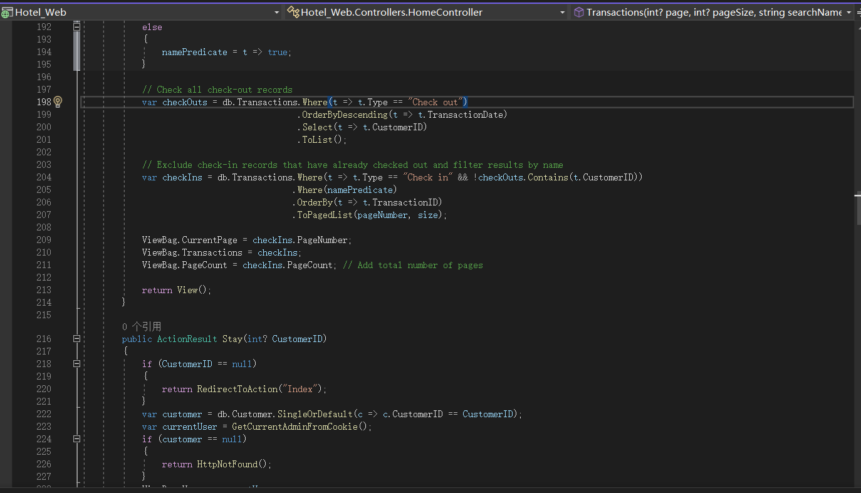

Filtering Function

Jump according to the items selected in bar, as shown in the figure below

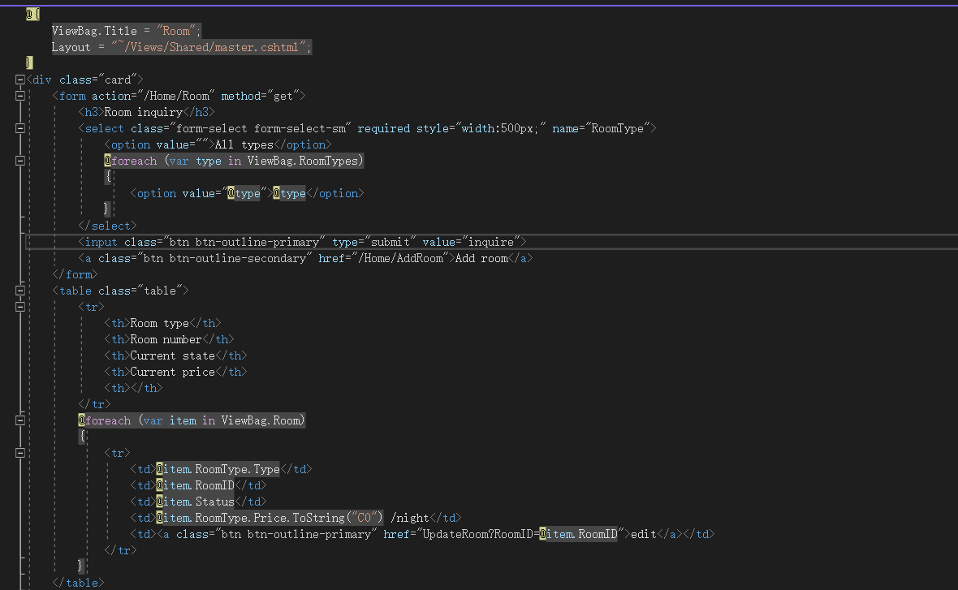



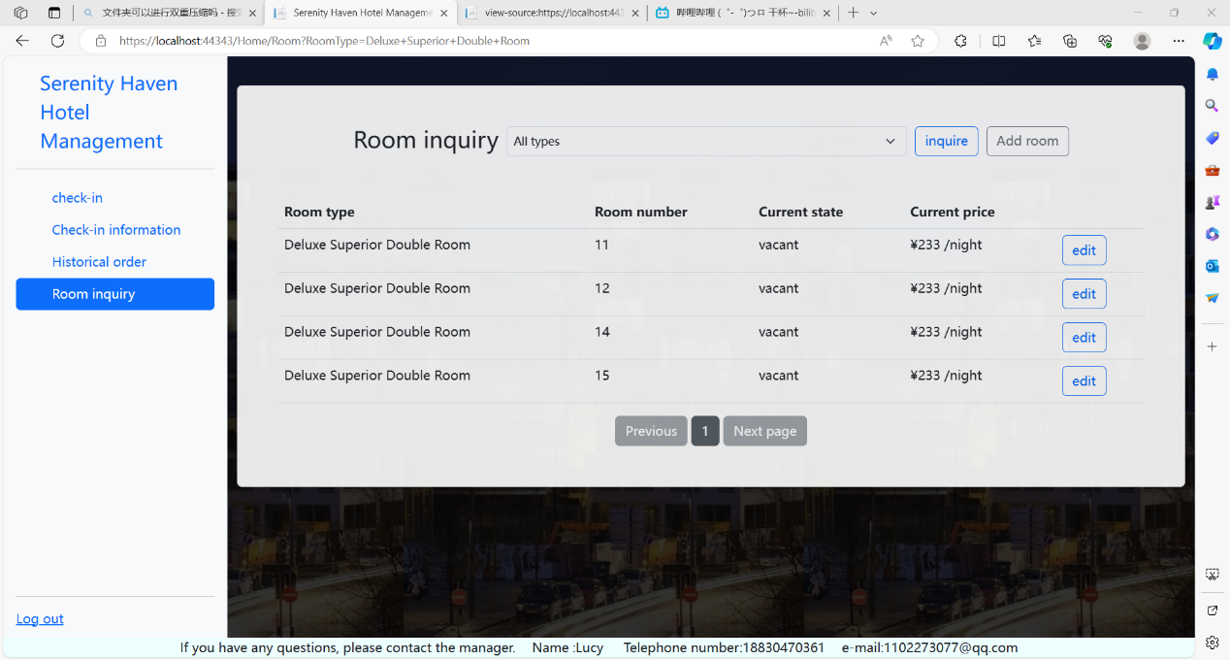

Paging Function

Paging is used here to get the user first and then all the order information for the user. Call the paging method, store the calculated value in the ViewBag for the view to use, and finally add the paging function.

